

A

Project Report

On

FoodGPT

Prepared by

23CS005 Dhruv Bhagat bhagat

23CS009 Devang Bhatt

23CS015 Jainish Chauhan

Under the
guidance

of

Prof.
/Dr.

Akshita Kadam

Submitted to

Charotar University of Science
&

Technology

De
gree

of
Bachelor

of Technology

in
Computer

Science &

Engineering

CSE204
:

Project
-
I

o
f
3
rd
Semester

of

B.
Tech

Submitted at

DEPARTMENT OF
COMPUTER

SCIENCE &

ENGINEERING

Faculty of Technology & Engineering, CHARUSAT

Chandubhai S. Patel Institute of Technolo
gy

(
CSPIT
)

At:

Changa
,

Dist: Anand
–

388421

October

2024

This is to certify that the report entitled “FoodGPT” is a bonafied work carried out by 23CS005 Dhruv Bhagat under the guidance and supervision of Akshita Kadam for the subject Project-I (CSE204) of 3rd Semester of Bachelor of Technology in Computer Science & Engineering at Chandubhai S. Patel Institute of Technology (CSPIT), Faculty of Technology & Engineering (FTE) – CHARUSAT, Gujarat.

To the best of my knowledge and belief, this work embodies the work of candidate himself, has duly been completed, and fulfils the requirement of the ordinance relating to the B.Tech. Degree of the University and is up to the standard in respect of content, presentation and language for being referred to the examiner.

Under the supervision of,

Akshita Kadam
Asst. Professor
Dept. of Computer Science & Engineering CSPIT,
CHARUSAT-Changa.

Dr. Amit Thakkar  Head of Department,  Dept. of Computer Science &  Engineering  CSPIT, CHARUSAT-Changa. |  | Dr. Trushit Upadhyaya  Principal,  CSPIT,  CHARUSAT-Changa.

This is to certify that the report entitled “FoodGPT” is a bonafied work carried out by 23CS009 Devang Bhatt under the guidance and supervision of Akshita Kadam for the subject Project-I (CSE204) of 3rd Semester of Bachelor of Technology in Computer Science & Engineering at Chandu Bhai S. Patel Institute of Technology (CSPIT), Faculty of Technology & Engineering (FTE) – CHARUSAT, Gujarat.

To the best of my knowledge and belief, this work embodies the work of candidate himself, has duly been completed, and fulfills the requirement of the ordinance relating to the B.Tech. Degree of the University and is up to the standard in respect of content, presentation and language for being referred to the examiner.

Under the supervision of,

Akshita Kadam
Asst. Professor
Dept. of Computer Science & Engineering CSPIT, CHARUSAT-Changa.

Dr. Amit Thakkar  Head of Department,  Dept. of Computer Science &  Engineering  CSPIT, CHARUSAT-Changa. |  | Dr. Trushit Upadhyaya  Principal,  CSPIT,  CHARUSAT-Changa.

This is to certify that the report entitled “FoodGPT” is a bonafied work carried out by 23CS015 Jainish Chauhan under the guidance and supervision of Akshita Kadam for the subject Project-I (CSE204) of 3rd Semester of Bachelor of Technology in Computer Science & Engineering at Chandubhai S. Patel Institute of Technology (CSPIT), Faculty of Technology & Engineering (FTE) – CHARUSAT, Gujarat.

To the best of my knowledge and belief, this work embodies the work of candidate himself, has duly been completed, and fulfills the requirement of the ordinance relating to the B.Tech. Degree of the University and is up to the standard in respect of content, presentation and language for being referred to the examiner.

Under the supervision of,

Akshita Kadam
Asst. Professor
Dept. of Computer Science & Engineering CSPIT, CHARUSAT-Changa.

Dr. Amit Thakkar  Head of Department,  Dept. of Computer Science &  Engineering  CSPIT, CHARUSAT-Changa. |  | Dr. Trushit Upadhyaya  Principal,  CSPIT,  CHARUSAT-Changa.

DECLARATION BY THE JAINISH CHAUHAN, DHRUV BHAGAT

DEVANG BHATT

We

hereby declare that the project report entitled “
FoodGPT
”
submitted by
us

to

Chandubhai S. Patel Institute of Technology (CSPIT)
, Changa in partia
l
fulfilment of the requirements
for the award of the degree of
B.Tech

Computer

Science
&

Engineering
,
from
the
Department of Computer

Science &

Engineering,
CSPIT
,
FTE

is a record of bonafide
CSE204

Project
-
I

carried out by
us

Underthe guidanceof
Prof.

Akshitaa
Kadam
.
We

further declare that the work
carried out and documented

in this project
report
has not been submitted
anywhere else either in part or in full and it is the original work
, for
the award of any other degree or diploma in this institute or
any other institute or university.

Signature of the candidate

23CS005 Dhruv Bhagat

Signature of the candidate

23CS009 Devang Bhatt

Signature of the candidate

23cs015 Jainish Chauhan

This is to certify that the above statement made by the candidate is correct to the best
of my knowledge.

Akshita Kadam

Asst. Professor

Department

of Computer

Science &

En
gineering
,

Chandubhai S. Patel Institute of Technology (CSPIT)

Faculty of
Technology

&

Engineering

(
FTE
)

Charotar University of Science and Technology (
CHARUSAT

)
-

Changa.

Contents
ABSTRACT 1
CHAPTER 1: INTRODUCTION 2
CHAPTER 4: TECHNOLOGY STACK 9
CHAPTER 5: SYSTEM DESIGN 11
CHAPTER 6: TESTING 15
CHAPTER 7: RESULTS 17
CHAPTER 8: CHALLENGES FACED 20
CHAPTER 9: CONCLUSION & FUTURE SCOPE 22

ABSTRACT

The FoodGPT website offers a dynamic and user-centric platform for individuals seeking meal ideas based on the ingredients they have on hand. Users can input a list of available ingredients, and the website instantly generates a variety of recipe suggestions that incorporate those ingredients. Each recipe is accompanied by detailed instructions, estimated preparation times, nutritional information, and serving suggestions. Through a user-friendly interface, the website enhances the cooking experience by helping users make the most out of their pantry items, reduce food waste, and discover new dishes tailored to their tastes and dietary needs. The project uses technologies like HTML, CSS and JAVA SCRIPT with a local server setup through API.

CHAPTER 1: INTRODUCTION

Welcome to FoodGPT, the ultimate solution for home cooks who want to make the most of their pantry and fridge ingredients. Tired of staring at your kitchen staples and wondering what to make? Simply enter the ingredients you have on hand, and our platform will instantly provide you with a wide variety of recipe ideas tailored to your preferences. From quick and easy meals to gourmet creations, FoodGPT helps you find new ways to use what’s already in your kitchen.
Our smart search engine takes into account not only the ingredients you input but also your dietary restrictions, cooking skill level, and meal preferences—whether you're craving something vegetarian, gluten-free, or low-carb. Each recipe comes with step-by-step instructions, estimated prep times, and nutritional information to guide you through every dish.
FoodGPT empowers you to create meals that suit your lifestyle and satisfy your taste buds. It’s never been easier to turn what’s in your fridge into something delicious and exciting. Try it out and discover a world of recipes waiting to be made!
The system is built using APi for backend operations, HTML/CSS for frontend design with JS.

Background:

FoodGPT was created to solve the common problem of figuring out what to cook with the ingredients you already have. In a world where busy schedules and rising food costs are the norm, many people struggle to make meals that are both easy and satisfying. The platform aims to reduce food waste by offering personalized recipe suggestions based on available ingredients. It also supports various dietary preferences, such as vegetarian, gluten-free, or low-carb, ensuring that everyone can find something suited to their needs. By simplifying meal planning and encouraging creativity, Recipe Finder helps users make the most of their kitchen staples while saving time and money.

Problem Definition:

People often struggle with figuring out what to cook using the ingredients they already have at home. This leads to food waste, extra trips to the grocery store, and the frustration of not knowing how to use up leftovers. For those with specific dietary needs (like vegetarian or gluten-free), finding recipes that work with what’s in the kitchen can be even harder. Additionally, there are so many recipes online, it’s easy to feel overwhelmed and unsure where to start.
FoodGPT solves these problems by helping users quickly find recipes based on the ingredients they have on hand. It saves time, reduces waste, and offers meal options that fit dietary needs, making cooking easier and more efficient.
Motivation:

FoodGPT was created to make cooking easier, reduce food waste, and save time and money. Many people struggle to use up ingredients before they spoil, leading to waste and unnecessary grocery trips. The platform helps users quickly find recipes based on what they already have, minimizing waste and encouraging creativity. It also supports various dietary needs, making it easier for everyone to find suitable meals. The goal is to simplify meal planning, inspire cooking, and make the most of what’s already in the kitchen.
Objectives and Scope:

Objectives:
- Maximize Ingredient Usage.
- Personalized Recipe Suggestions.
- Save Time.
- Support Diverse Diets.

Scope:
- Ingredient-based recipe search.
- Filters for dietary preferences and meal types.
- Easy-to-use interface for quick meal planning.

CHAPTER 2: LITERATURE REVIEW:

The literature suggests that ingredient-based recipe recommendation systems have significant potential to help individuals cook more efficiently, reduce food waste, and cater to specific dietary preferences. Personalization, ease of use, and sustainability are key factors that influence the success and adoption of these platforms. The growing interest in health-conscious eating and environmentally sustainable practices further underscores the importance of platforms like FoodGPT, which can support individuals in making smarter, more creative meal choices.

COMPARATIVE ANALYSIS OF EXISTING PLATFORMS:

Each platform offers unique features catering to different user needs. SuperCook and Fridge to Table excel in ingredient-based searching, which is ideal for users looking to minimize waste.
Yummly and Eat This Much stand out with their high level of personalization, making them better for users with specific dietary goals or health concerns.
AllRecipes offers a vast recipe database but lacks the depth of ingredient-based searching.
Tasty, while visually engaging, is better suited for users seeking simple, quick recipes rather than complex meal planning.
For a Recipe Finder platform, combining the best aspects of these platforms—ingredient-based search, dietary filters, and personalization—would provide users with a versatile, easy-to-use tool for efficient and creative meal planning.

UNIQUE FEATURES IN THE DEVELOPED SYSTEM:

1. Ingredient-Based Search:
Allows users to input available ingredients and find recipes that match those ingredients.
2. Dietary Preferences Filters:
Enables users to filter recipes based on dietary needs (e.g., vegetarian, gluten-free, nut-free, etc.).

3. Recipe Details:
Provides step-by-step instructions, cooking time, serving sizes, and nutritional information for each recipe.

4. User-Friendly Interface:
Simple, intuitive design that makes it easy for users to search, filter, and navigate through recipe options.

5. Meal Planning Assistance:
Helps users plan meals for the week by suggesting recipes that fit their available ingredients and dietary preferences.

These features ensure the platform is functional, efficient, and user-friendly while focusing on the core needs of a recipe finder website.
CHAPTER 3: SYSTEM ANALYSIS

FUNCTIONAL REQUIREMENTS:

- Ingredient Input and Recipe Search
- Dietary Preference Filters
- Recipe Display
- Meal Planning
- Ingredient Substitution Suggestions
- Responsive Design
- Search History and Preferences
- Nutritional Information

NON-FUNCTIONAL REQUIREMENTS:

- Performance and Speed
- Scalability
- Availability and Uptime
- Security
- Usability and Accessibility
- Compatibility
- Maintainability
- Backup and Recovery
- Legal and Compliance

CHAPTER 4: TECHNOLOGY STACK

LANGUAGES:

HTML,CSS and JS for frontend, Spoonacular API

//SERVER:

WHY THESE TOOLS? :

- HTML: HTML provides the essential structure of the webpage, defining where elements like input fields and recipe displays are placed. It acts as the foundation for organizing content that JavaScript and CSS can enhance.
- CSS: CSS styles the HTML elements, making the interface visually appealing and user-friendly. It ensures the recipe site is attractive, consistent, and responsive across devices.
- JavaScript: JavaScript enables interactivity by capturing user input and communicating with the Spoonacular API to fetch and display recipes. It adds dynamic functionality, allowing content to update without refreshing the page.

CHAPTER 5: SYSTEM DESIGN

USE CASE DIAGRAM:

Users can search recipes, view recipe, save, rate and review.
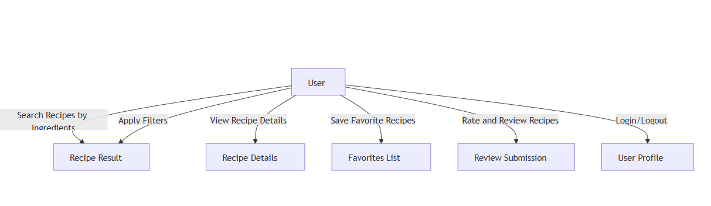

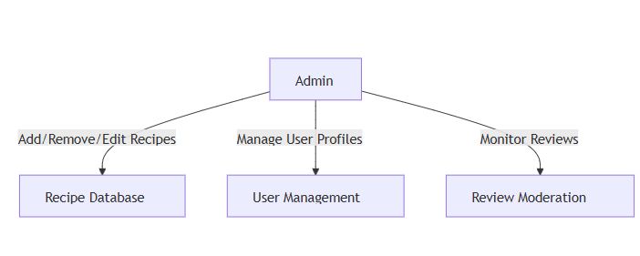

Fig 5.1 Use Case Diagram

ARCHITECTURE DESI

SPOONACULAR API IMPLEMENTATION
Spoonacular API automatically analyses recipes to check for ingredients that contain common allergens, such as wheat, dairy, eggs, soy, nuts, etc. It also determines whether a recipe is vegan, vegetarian, Paleo friendly, Whole30 compliant, and more.
It makes it easy to add a recipe search to your app or website - and not just any recipe search. Their semantic search is fast, accurate.

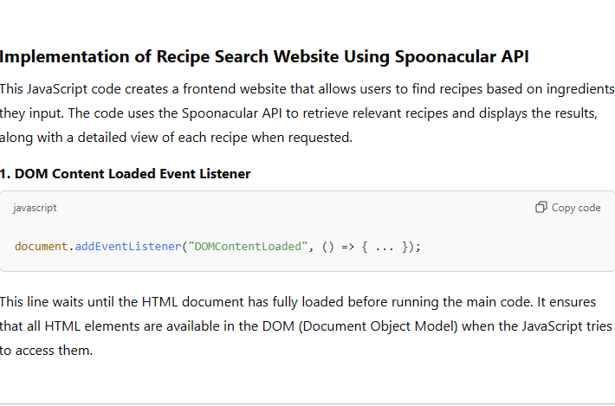
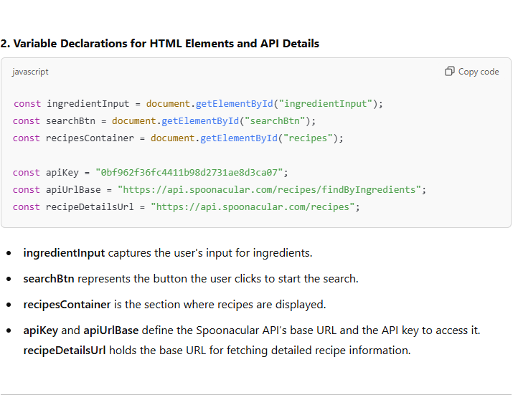

UI/UX DESIGN:
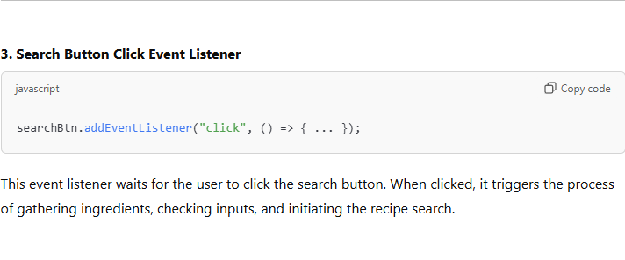
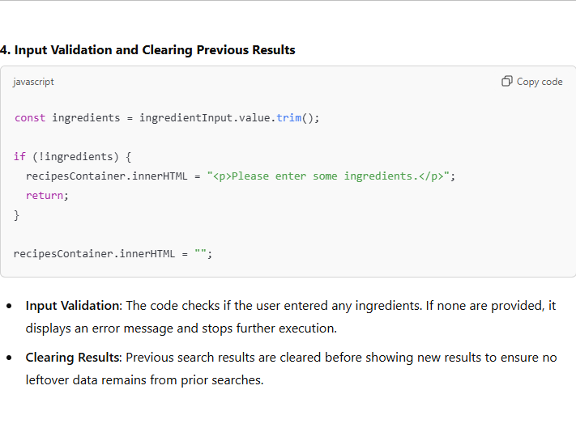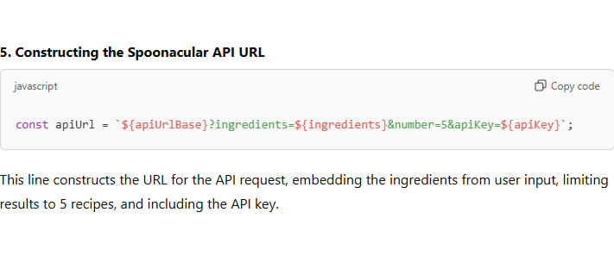
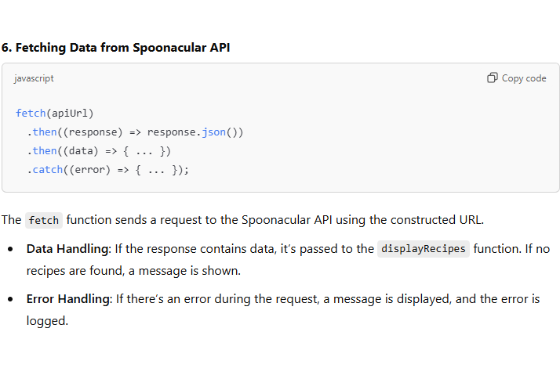
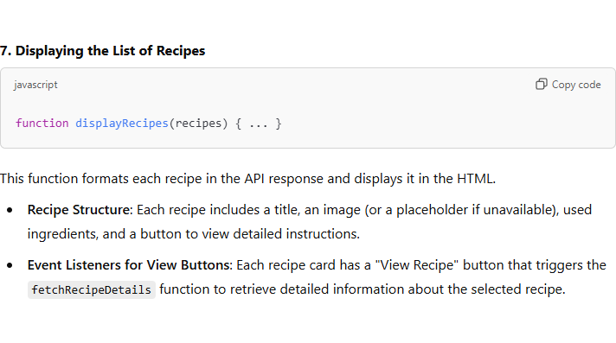
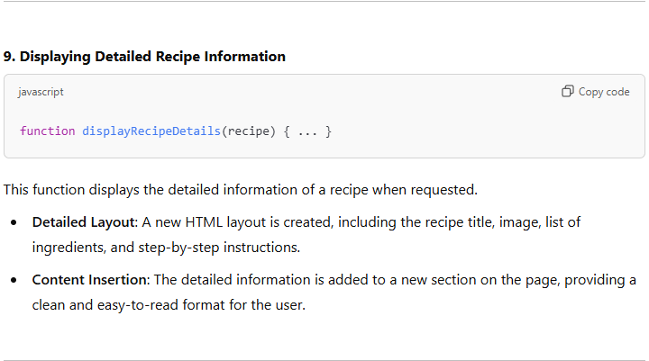
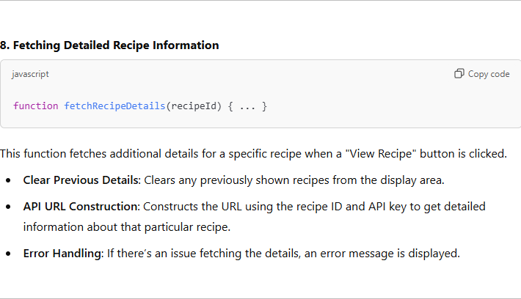

UI/UX DESIGN

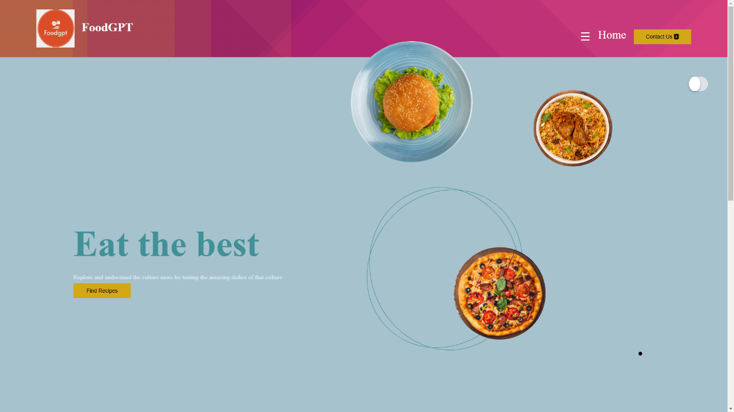


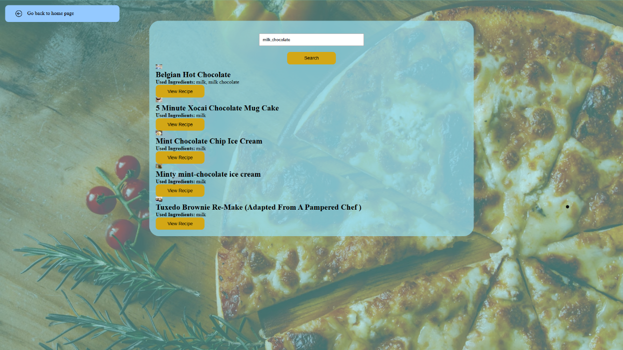
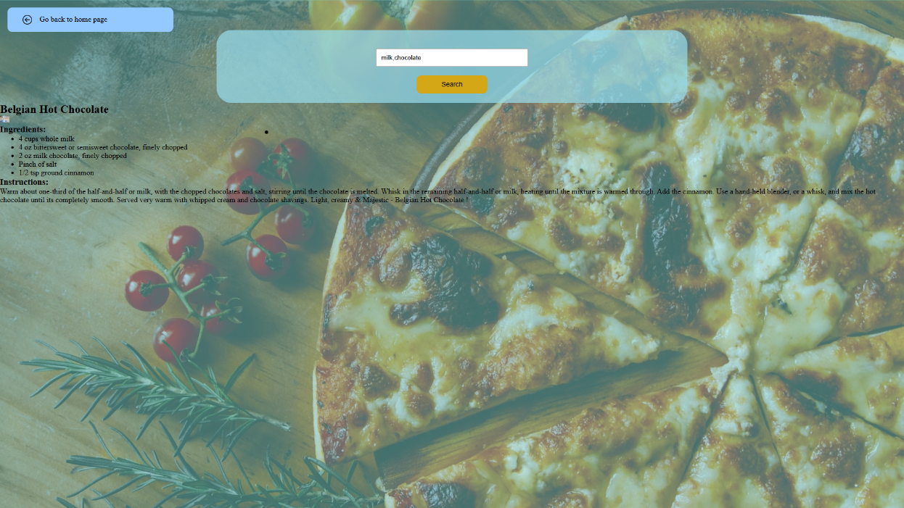

CHAPTER 6: TESTING

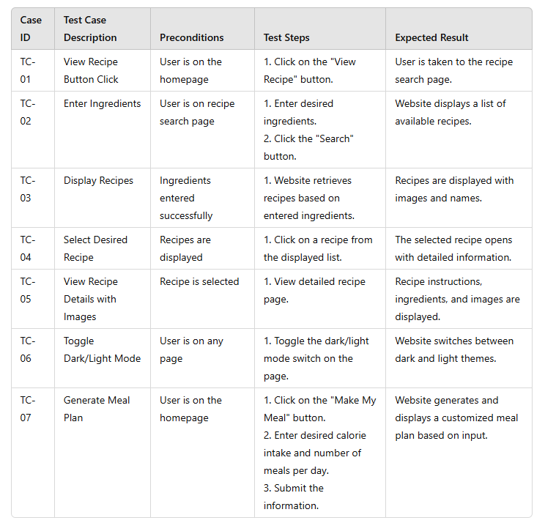

CHAPTER 7: RESULTS

OVERVIEW OF TESTING OUTCOMES:

Search Recipes by Ingredients
- Outcome: The search functionality performed as expected, accurately matching recipes based on the ingredients entered by the user.
- Issue: Minor issue with matching recipes that contain similar ingredients but not exact matches.
View Recipe Details
- Outcome: Recipe details (ingredients, instructions, cooking time, nutritional information) displayed correctly for all tested recipes.
- Issue: None. All data presented was accurate and complete.

Recommendations
- Outcome: Displays popular recipes and suggests other websites for detailed description
- Issue: Currently the admin has to manually update the must try recipes and there is lack of an automated approach.

KEY FEATURE DEVELOPED:

1. Ingredient-Based Recipe Search
- Feature: Allows users to input available ingredients and find recipes that match or use those ingredients. This feature helps reduce food waste and provides a quick solution to users with limited ingredients.
- Key Benefit: Helps users make the most of what they have on hand and minimizes the need for extra grocery shopping.

2. Recipe Details and Nutritional Information
- Feature: Displays detailed instructions, ingredients, cooking time, servings, and nutritional breakdown for each recipe.
- Key Benefit: Users can make informed choices about the recipes they follow, ensuring they meet their dietary goals and preferences.

3. Recommendations
- Feature: Displays popular recipes and suggests other websites for detailed description
- Key Benefit: Enhances the user experience by offering suggestions that fit individual tastes and dietary restrictions.

CHAPTER 8: CHALLENGES FACED

- Recipe Matching Accuracy
  - Problem: Ensuring that the website matches recipes based on the ingredients users have, especially when the ingredients are not entered perfectly or may have different names.
  - Solution: Improved the search algorithm to recognize variations in ingredient names and partial matches.
- Dietary Preferences and Filters
  - Problem: Currently we have attached the link of a third party website for dietary recommendations.
  - Solution: Working on a filtering system that lets users apply multiple dietary preferences and meal types at once, ensuring they get relevant results.
- Performance and Scalability
  - Problem: The website needed to handle lots of users and recipes without slowing down and the api used supports limited user for a free trial.
  - Solution: The premium version of the API has to be purchased.
- Cross-Device Compatibility
  - Problem: Ensuring the website worked well on all devices (phones, tablets, desktops).
  - Solution: Used responsive design to adjust the layout and features automatically based on the user’s screen size, ensuring a good experience on any device.
- Regional Ingredients and Language
  - Problem: Different countries use different names for ingredients, and users may speak different languages.
  - Solution: Currently working on adding language options and standardized ingredient names to make the website easier to use for people worldwide.
- Personalized Recipe Suggestions
- Problem: Currently the admin has to manually update the must try recipes and there is lack of an automated approach.

- Solution: Currently working on adding a system that learns from user interactions (e.g., past searches and saved recipes) to suggest recipes tailored to each user.
- User Interface (UI) and Experience (UX)
- Problem: Making sure the website is easy to use, even for people who aren't experienced cooks.
- Solution: Focused on a simple, intuitive design and tested it with users to ensure it was easy to navigate and use for both beginners and experts.

CHAPTER 9: CONCLUSION & FUTURE SCOPE

Conclusion: FoodGPT Website has successfully addressed the core need of helping users discover and create meals based on the ingredients they already have on hand. Through a user-friendly interface and advanced features like personalized recipe search, dietary filters, and meal planning, the platform offers a comprehensive and intuitive solution to modern cooking challenges. Key features such as ingredient-based search, and the ability to save favourite recipes have been thoroughly tested and optimized to deliver an exceptional user experience.
The website has also shown strong performance, security, and scalability, ensuring that it can handle growing user numbers while providing a fast and secure service. The feedback from user testing has been overwhelmingly positive, with users appreciating the ability to organize their meals, minimize food waste, and make healthier cooking choices. However, some areas for further improvement were identified during the testing phase, which will be addressed in upcoming updates.

Future Scope
- Integration with Smart Kitchen Devices
  - Scope: In the future, the website could integrate with smart kitchen appliances (e.g., smart ovens, fridges) to automatically adjust cooking settings based on selected recipes or notify users when they’re running low on ingredients.
  - Benefit: This would enhance user convenience by automating parts of the cooking process and help reduce food waste by tracking ingredient usage.
- AI-Powered Personalized Recommendations
  - Scope: The platform could incorporate more advanced AI to provide deeper insights into user preferences, dietary habits, and health goals, offering highly personalized recipe suggestions based on data such as previous ratings, nutritional requirements, and seasonal ingredients.
  - Benefit: This would further optimize the user experience, making recipe suggestions even more tailored and relevant.
- Voice Interaction Expansion
  - Scope: Expanding the voice-assisted cooking feature to include voice interaction throughout the entire meal preparation process, allowing users to interact hands-free for each step (e.g., checking ingredient quantities, adjusting cooking times).
  - Benefit: This would increase accessibility and convenience, especially for people with disabilities or those who prefer a more interactive cooking experience.
- Enhanced Social Features
  - Scope: Introducing community features, such as recipe sharing, social media integration, and user-generated content, would allow users to interact, share their cooking experiences, and get inspired by others.
  - Benefit: A social element could increase engagement and provide users with more diverse recipe ideas and inspiration from a wider community.
- Integration with Grocery Delivery Services
  - Scope: Partnering with grocery delivery services like Instacart or Amazon Fresh to allow users to directly order ingredients from their shopping lists.
  - Benefit: This would save users time by streamlining the entire cooking process, from recipe discovery to ingredient acquisition.
- Expanded Dietary Filter Options
  - Scope: Future versions could introduce more detailed dietary filters for specific conditions such as keto, paleo, low FODMAP, or heart-healthy diets.
  - Benefit: This would make the platform more inclusive and cater to users with specific dietary needs, enhancing accessibility for people with health conditions or food sensitivities.
- Mobile App Development
  - Scope: Developing a native mobile application for both iOS and Android platforms to provide a more optimized experience on mobile devices, including offline access to saved recipes and meal plans.
  - Benefit: A mobile app would give users greater flexibility and enhance accessibility, allowing them to cook with the website’s features even when not connected to the internet.
- Internationalization and Multi-Language Support
  - Scope: Expanding the platform to support multiple languages and regional ingredient variations, which would make it more accessible to a global audience.
  - Benefit: This would increase the user base and offer the Recipe Finder Website to people from different cultures with diverse tastes and preferences.
- Sustainability Features
  - Scope: Introducing sustainability-focused features, such as tracking the environmental impact of recipes (e.g., carbon footprint of ingredients) and offering recipes with more eco-friendly ingredients.
  - Benefit: This would cater to the growing interest in sustainable eating habits and environmentally conscious cooking, helping users make more eco-friendly food choices.

CHAPTER 10: REFERENCES

